22 Editors - Info Editor
Info Editor 1
Header 1
View Menu 2
Area Menu 2
Horizontal Split 2
Vertical Split 2
Duplicate Area into new Window 2
Toggle Maximize Area 2
Toggle Fullscreen Area 2
Console Menu 2
Select All 2
Deselect All 3
Invert Select 3
Toggle Selection 3
Copy 3
Delete 3

Info Editor

The Info Editor has just one purpose. It lists the performed operations in the current session. And displays them as Python commands. Here you can also find error messages.
You can find the Info Editor in the scripting layout down left.
You can copy text from the Info Editor by marking some text, and then use the hotkey ctrl + c to copy it.

Header
In the Scripting Layout the header of the Info Editor is collapsed. Pull it down to reveal it. The Editor Type menu is explained in chapter 6 Editors introduction.

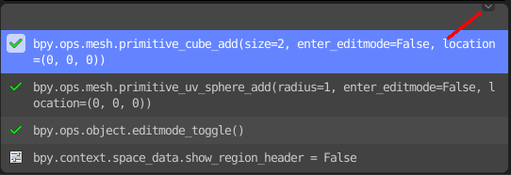

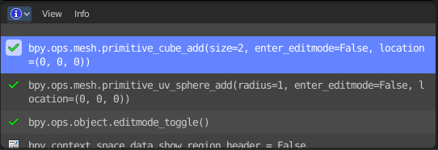

View Menu
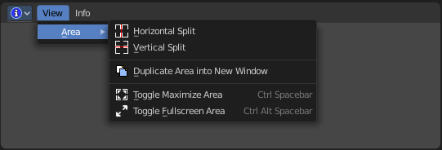

Area Menu
Area is a menu with window related settings.

Horizontal Split
Splits the editor horizontally into two editors.

Vertical Split
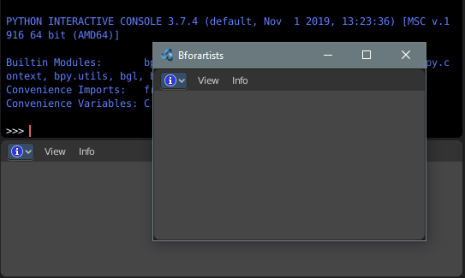
Splits the editor vertically into two editors.

Duplicate Area into new Window
Creates a floating window out of the current editor.

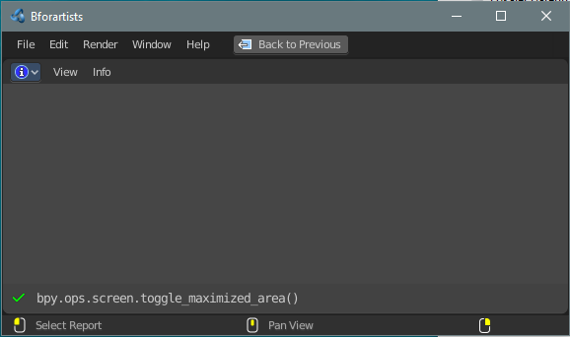
Toggle Maximize Area
Displays the editor maximized with menus.
To return to split view press hotkey Ctrl Spacebar, click at the Back to Previous button, or reuse the menu item in the View menu.

Toggle Fullscreen Area
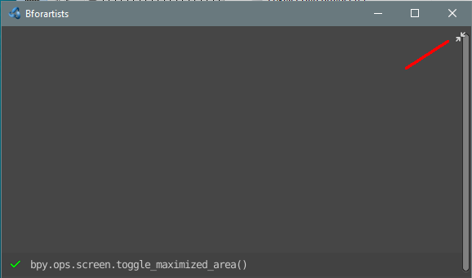
Displays the editor maximized without menus.
To return from the full screen view press hotkey Ctrl Alt Spacebar, or use the little button that appears up right when you move the mouse in this corner.

Console Menu

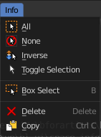
The Console menu provides some console editor window specific functionality.

Select All
Select all.

Deselect All
Select nothing.

Invert Select
Inverts the selection.

Toggle Selection
Toggles the selection.

Copy
Copies selected content.

Delete
Deletes selected content.

